**GPS Output frames**

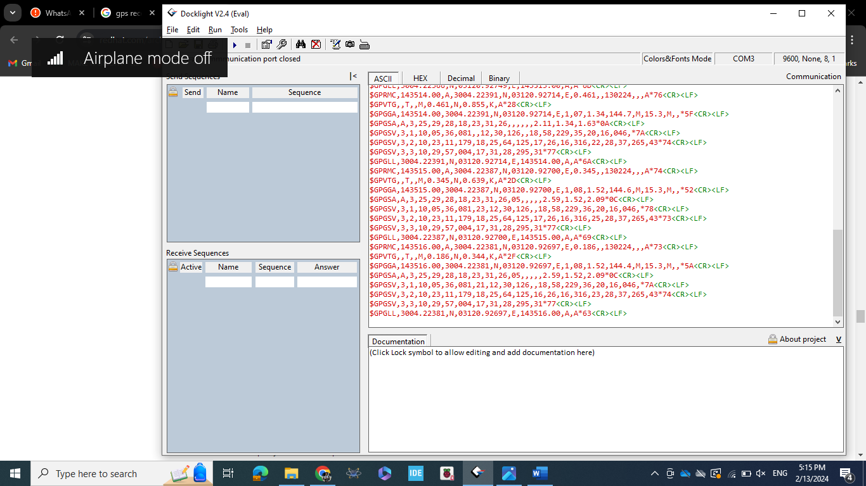

**GPGGA Example:**

$GPGGA,170241.00,3401.21189,N,11824.67797,W,1,06,2.14,71.6,M,-32.9,M,,*57

Field Description:

|  |  |  |  |
| --- | --- | --- | --- |
| **Position** | **Field Name** | **Example Data** | **Description** |
| 0 | Sentence Type Identifier | $GPGGA | GGA protocol header |
| 1 | Time | 170241 | 17:02:41 UTC |
| 2 | Latitude | 3401.21189 | ddmm.mmmm format, converts to 34.020196 or 34d 1' 12.706" N |
| 3 | Latitude Hemisphere | N | N = North, S = South |
| 4 | Longitude | 11824.67797 | dddmm.mmmm format, converts to -118.41129833 or 118d 24' 48673" W |
| 5 | Longitude Hemisphere | W | W = West, E = East |
| 6 | - 0 = Invalid  - 1 = GPS fix  - 2 = DGPS fix | 1 | Data is from a GPS fix |
| 7 | Number of Satellites | 06 | 6 Satellites are in view |
| 8 | Horizontal Dilution of Precision (HDOP) | 2.14 | Relative accuracy of horizontal position |
| 9 | Altitude | 71.6 | 71.6 meters above mean sea level |
| 10 | Altitude Units | M | M = meters |
| 11 | Height of geoid above WGS84 ellipsoid | -32.9 | -32.9 meters |
| 12 | Height of geoid above WGS84 ellipsoid Units | M | M = meters |
| 13 | Time since last DGPS update | blank | No last update |
| 14 | DGPS reference station id | blank | No station id |
| 15 | Checksum | *57 | Used by program to check for transmission errors |

**GPGLL Example:**

$GPGLL, 3723.2475, N, 12158.3416, W, 161229.487, A, A*41

Field Description:

|  |  |  |  |
| --- | --- | --- | --- |
| **Position** | **Field Name** | **Example** | **Description** |
| 0 | Message ID | $GPGLL | GLL protocol header |
| 1 | Latitude | 3723.2475 | ddmm.mmmm |
| 2 | N/S indicator | N | N =North or S = south |
| 3 | Longitude | 12158.3416 | dddmm.mmmm |
| 4 | E/W indicator | W | E =East or W = West |
| 5 | UTC time | 161229.487 | hhmmss.sss |
| 6 | Status | A | A = data valid or V = data not valid |
| 7 | Mode | A | A =Autonomous , D =DGPS, E =DR (This field is only present in NMEA version 3.0) |
| 8 | Checksum | *41 |  |
| 8 | <CR><LF> |  | End of message termination |

**GPVTG Example:**

$GPVTG, 309.62, T, ,M, 0.13, N, 0.2, K, A*23

Field Description:

|  |  |  |  |
| --- | --- | --- | --- |
| **Position** | **Field Name** | **Example** | **Description** |
| 0 | Message ID | $GPVTG | VTG protocol header |
| 1 | Course | 309.62 | Degrees |
| 2 | Reference | T | True |
| 3 | Course | blank | Degrees |
| 4 | Reference | M | Magnetic |
| 5 | Speed | 0.13 | Knots, measured horizontal speed |
| 6 | Units | N | Knots |
| 7 | Speed | 0.2 | Km/Hr, measured horizontal speed |
| 8 | Units | K | Kilometers per hour |
| 9 | Mode | A | A = Autonomous, D = DGPS, E = DR |
| 10 | Checksum | *23 |  |
| 11 | <CR><LF> |  | End of message termination |

**GPRMC Example:**

$GPRMC, 161229.487, A, 3723.2475, N, 12158.3416, W, 0.13, 309.62, 120598, , *10

Field Description:

|  |  |  |  |
| --- | --- | --- | --- |
| **Position** | **Field Name** | **Example** | **Description** |
| 0 | Message ID | $GPRMC | RMC Protocol Header |
| 1 | UTC time | 161229.487 | hhmmss.sss |
| 2 | Status | A | A = data valid or V = data not valid |
| 3 | Latitude | 3723.2475 | ddmm.mmmm |
| 4 | N/S indicator | N | N = North or S = South |
| 5 | Longitude | 12158.3416 | dddmm.mmmm |
| 6 | E/W indicator | W | E = East or W = West |
| 7 | Speed over ground | 0.13 | Knots |
| 8 | Course over ground | 309.62 | Degrees |
| 9 | Date | 120598 | ddmmyy |
| 10 | Magnetic Variation |  | Degrees (E= East or W = West) |
| 11 | Mode | A | A = Autonomous, D = DGPS, E =DR |
| 12 | Checksum | *10 |  |
| 13 | <CR><LF> |  | End of message termination |

**GPGSA Example:**

$GPGSA,M,3,17,02,30,04,05,10,09,06,31,12,,,1.2,0.8,0.9*35

|  |  |  |  |
| --- | --- | --- | --- |
| **Position** | **Field Name** | **Example** | **Description** |
| 0 | Message ID | $GPGSA | GSA Protocol Header |
| 1 | Mode | M | M=Manual, forced to operate in 2D or 3D, A=Automatic, 3D/2D |
| 2 | Fix Quality | 3 | - 0 = Invalid  - 1 = GPS fix  - 2 = DGPS fix |
| 3 | PRN of Satellite Vehicle | 17 | Pseudo-random noise (PRN) sequence (a.k.a Gold code) of the satellite. You can think of the PRN as a code that uniquely identifies a particular satellite. |
| 4 | PRN of Satellite Vehicle | 02 | See description at row 3 |
| 5 | PRN of Satellite Vehicle | 30 | See description at row 3 |
| 6 | PRN of Satellite Vehicle | 04 | See description at row 3 |
| 7 | PRN of Satellite Vehicle | 05 | See description at row 3 |
| 8 | PRN of Satellite Vehicle | 10 | See description at row 3 |
| 9 | PRN of Satellite Vehicle | 09 | See description at row 3 |
| 10 | PRN of Satellite Vehicle | 06 | See description at row 3 |
| 11 | PRN of Satellite Vehicle | 31 | See description at row 3 |
| 12 | PRN of Satellite Vehicle | 12 | See description at row 3 |
| 13 | PRN of Satellite Vehicle | blank | See description at row 3 |
| 14 | PRN of Satellite Vehicle | blank | See description at row 3 |
| 15 | Position Dilution of Precision (PDOP | 1.2 | The 3D Position Dilution of Precision (PDOP) |
| 16 | Horizontal Dilution of Precision (HDOP) | 0.8 | Dilution of Precision |
| 17 | Vertical Dilution of Precision (VDOP) | 0.9*35 | Dilution of Precision |
|  | <CR><LF> |  | End of message termination |

**GPGSV Example:**

$GPGSV,3,1,11,18,87,050,48,22,56,250,49,21,55,122,49,03,40,284,47*78

|  |  |  |  |
| --- | --- | --- | --- |
| **Position** | **Field Name** | **Example** | **Description** |
| 0 | Message ID | $GPGSV | GSV Protocol Header |
| 1 | number message | 3 | Total number of messages (1-9) |
| 2 | Message number | 1 | Total number of messages of this type in this cycle |
| 3 | Number of satellites | 11 | Total number of satellites in view |
| 4 | Satellite #1 PRN Number | 18 | Pseudo-random noise (PRN) sequence of the satellite.  GPS = 1 to 32  Galileo = 1 to 36  Beidou = 1 to 63  NAVIC = 1 to 14  QZSS = 1 to 10  SBAS = 33 to 64 (add 87 for PRN#s)  GLO = 65 to 96 1 |
| 5 | Elevation | 87 | Elevation in degrees, 90 maximum |
| 6 | Azimuth | 050 | Azimuth, degrees from true north, 000 to 359 |
| 7 | SNR | 48 | SNR, 00-99 dB (null when not tracking) |
| 8 | Satellite #2 PRN Number | 22 | Information about second SV, same as fields 4-7 |
| 9 | Elevation | 56 | Information about second SV, same as fields 4-7 |
| 10 | Azimuth | 250 | Information about second SV, same as fields 4-7 |
| 11 | SNR | 49 | Information about second SV, same as fields 4-7 |
| 12 | Satellite #3 PRN Number | 21 | Information about third SV, same as fields 4-7 |
| 13 | Elevation | 55 | Information about third SV, same as fields 4-7 |
| 14 | Azimuth | 122 | Information about third SV, same as fields 4-7 |
| 15 | SNR | 49 | Information about third SV, same as fields 4-7 |
| 16 | Satellite #4 PRN Number | 03 | Information about fourth SV, same as fields 4-7 |
| 17 | Elevation | 40 | Information about fourth SV, same as fields 4-7 |
| 18 | Azimuth | 284 | Information about fourth SV, same as fields 4-7 |
| 19 | SNR | 47 | Information about fourth SV, same as fields 4-7 |
| 20 | Checksum | *78 |  |